How to Make Potato Vodka
Name
Institution
Date

HOW TO MAKE POTATO VODKA

AUDIENCE ANALYSIS:
Vodka is a regular drink that does not contain any addictive elements like tastes, aroma, or color. Thus, this instructional manual is meant to guide brewers to make the economical spirit from potatoes, which are readily available.
Essentially, the instructional page will enable local distillers to purify and refine potato-distilled vodka.
Users should observe to their municipality rules and by-laws relating to the brew of any liquor. Predominantly, those who want to distil potato-vodka for profitable purposes are counseled to adhere to all constitutional necessities to ensure observance to Food and Poisonous Requirement Act.
How to make potato Vodka
Crucial Steps
- Preparation of potatoes
- Conversion of starch into sugar
- Preparation and pitching yeast
- Fermenting and racking
- Three distillations
- Finishing

List of Equipment and Materials

Tools:
- Sharp Knife
- Jugs
- Large saucepan
- Chopping Board
- 2x25L fermenter filled with 23L of liquid at room temperature
- Stick blender
- Couple of old blankets
- Long plastic spoon
- 1xgallon Demijohn
- 1xalcohol hydrometer spirit
- Thermometer
- charcoal filter

Materials:
- 9kg-potatoes
- Wine yeast EC-1118
- Amylase
- 2kg-sugar
- 1kg-Barley Malt

The Distillation Process

1: PICKING THE INGREDIENTS
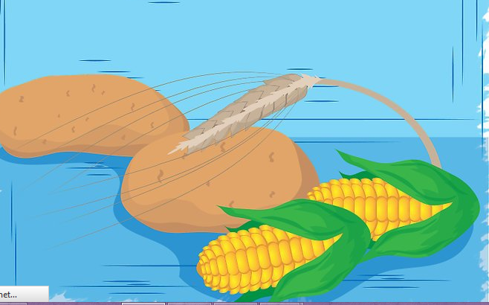
- The Ingredients include potatoes, corn, barley, wheat, and rye. Optional ingredients include –
- Sugar
- Molasses (although these can be used as standalone ingredients.)
When using potatoes and grains, use active-enzymes when mashing the ingredients because the enzymes will help convert the starch into glucose or any other simple sugars so that the yeast can thrive and ferment.
- Confirm if amount of the marsh ingredient is sufficient or not by consulting the formula shown below in figure 2

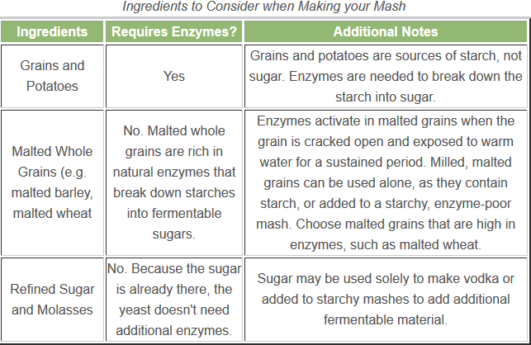
- Food-grade Amylase helps to speed the conversion of mashed potatoes into simple sugars constituents. Use the commended quantity as specified in the sticker.
Temperature regulation is key since temperatures above 70⁰C will denature the enzymes.

2: MARSHING THE POTATOES
- Wash 20 pounds of unpeeled potatoes for about one hour until they gelatinize.
- Get rid of the water and marsh the potatoes using hands or the stick blende
- Add 5 gallons of tap water
- Blend the mix at 60⁰C
- Add two pound of Barley malt
Or mashed wheat
- Cover the mixture and stir occasionally after every two hours.
A longer cooling period gives the enzymes time to break down the starch.

3: FERMENTATION
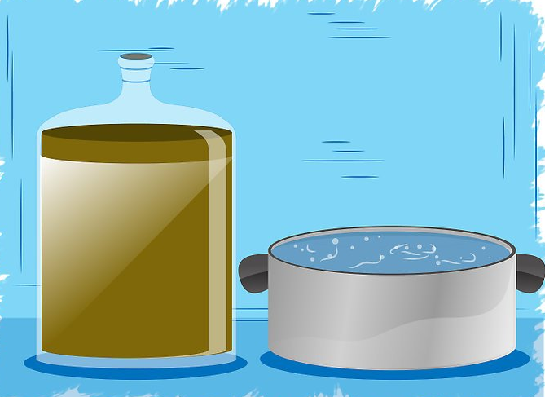
(Source, Ackland, 2011)
- Clean all utensils ensuring adequate sanitation to avoid unwanted flavors which are contrary to the principle of vodka brewing.
- Set the airlock mechanism which allows CO₂ gas to leak out while avoiding the entry of O₂ gas.
There is a possibility of explosion when one uses lead due to accumulation of excess CO₂ gas that will require affixing of airlock mechanism.
- Add yeast into the solution and stir using a clean plastic spoon.
- Collect the fermented liquid by tapping the wash product into the distillation apparatus.
- Leave the sediment where it is because it can scorch when heated.

4: DISTRILLATION PROCESS
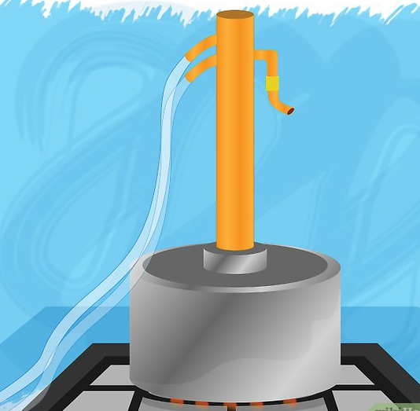
(Source, Ackland, 2011)
- Heat the comparatively low-alcoholic wash to a temperature slightly above the boiling point of the alcohol. The heating should be slightly below the BP of the water. Heating will vaporize the alcohol up through the column where exterior cooling will precipitate the hot vapor, which becomes the vodka when it cools.

5: FINAL TOUCHES
- Treat the collected vodka with a carbon filter.
- Dilute the vodka into the required alcoholic content.
- Bottle and brand you vodka!

REFERENCES
Auber, A. (March 27, 2017). “Forget Potatoes: New Texas Vodka Uses Black-eyed Peace instead,” CoxMediaGroup
Ackland, T. (2011). “Home Distillers of Alcohol,” ThoughtCo

